***PAAREES PERFUMES***

***Christian Diors***

***FOR MEN***

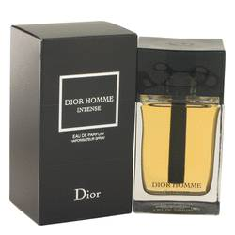

# *Dior Homme Intense*

***Description***

Dior Homme Intense by Christian Dior Cologne. If you're looking for a powerful musky men's scent that delivers superb longevity, Dior Homme Intense should be your go to fragrance. Introduced in 2007 by Christian Dior, top notes include fresh lavender and iris. A rugged base of Virginia cedar, vetiver and golden amber follow middle tones of pear and musk mallow for an appealing blend that is aromatic and hardy. Ideal for every day use, this concentrated fragrance lasts from morning to night time and has an appealing scent.